SCI: The change in the name and seal of the Company
On 10/05/2017, Song Da 9 Construction and Investment Joint Stock Company announced the change in the name and seal of the Company as follows:
- On 28/04/2017, General Meeting of Shareholders of Song Da 9 Construction and Investment Joint Stock Company approved changing its name into SCI E& C Joint Stock Company
- On 09/05/2017, the Company received Business Registration Certificate – sixth change granted by Hanoi Authority for Planning & Investment
The change in the seal
No. | The change information | Before change | After change
1 | Name of the Company | Song Da 9 Construction and Investment Joint Stock Company | SCI E& C Joint Stock Company
2 | Seal mode | 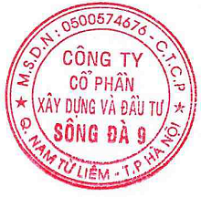 | 
3 | Email | ifo@sincco.com.vn | scienc@scigroup.vn
4 | Website | www.sincco.com.vn | www.sci-enc.com

